VT STORMWATER MANAGEMENT

FACT SHEET
Dewatering Activities
This fact sheet outlines best management practices regarding the discharge of water pumped from construction and maintenance activities. The Virginia Tech Site & Infrastructure Development (SID) Department offers erosion and sediment control guidance when dewatering or water pumping takes place on any Virginia Tech construction or maintenance activity. Please consult SID prior to beginning any construction or maintenance activity where land disturbance is involved. Refer to the contact information in the upper left corner of this document.

General Dewatering:

Dewatering is the practice of removing water from a work area through portable water pumps. This water is considered effluent. Effluent water is typically pumped out of the work area and into a filtering device(s) before being discharged from the site. Filtering devices and general erosion control practices should be used to manage water from the work area after being approved by SID. See Photos 1, 2, and 3 for general filtration techniques.

Dewatering Best Management Practices:
- The discharge areas should be chosen with careful consideration to the downstream receiving watercourses and the landscape’s ability to filter effluent from the dewatering process. A wooded buffer (with sufficient underbrush) or turf are preferred areas to discharge.
- Special attention should be paid to the buffer area for any sign of erosion and concentration of flow that may impact the buffer area.
- Minimize dewatering discharge velocity in order to avoid scouring the receiving area. Structural controls can be used to handle the anticipated flow/discharge (See General Erosion and Sediment Control Practices).
- A visual inspection of the effluent should be performed at the discharge point of the dewatering practice to determine if additional filtering may be needed.
- Inspect the dewatering site regularly to ensure that the discharge is adequately controlled.
- Inspect filtering bags for clogging and replace as necessary.
General Erosion and Sediment Control Practices:
- Protect Existing Features: Minimize the clearing of existing vegetation and the amount of exposed soil at the discharge point.

- Stabilize the area receiving discharge: Techniques such as sodding, seeding/ mulching and stone cover can be utilized to reduce the erosion of exposed soils and steep grades.
- Storm Drain Inlet Protection: Use and maintain inlet protection (See Photo 3).
- Filter Bag: Use a manufactured filtering device to reduce the amount of sediment from dewatering activities (See Photo 1).
- Rock Check Dam: Use a temporary or permanent erosion and sediment control measure that is constructed to filter sediment from runoff and can be used for filtering effluent from dewatering activities.
- Temporary Diversion Dike: Use a temporary erosion and sediment control measure to direct sediment-laden stormwater to a sediment trapping facility or stormwater management facility.
- Temporary Sediment Traps/Basins: Sediment trapping facilities are designed to detain sediment-laden runoff from disturbed areas long enough for sediment to settle out and control the release of stormwater. Dewatering effluent can be directed to these facilities to allow the sediment time to settle out.
Dewatering Bag Disposal:
- The silt bag and its contents can be disposed of as solid waste.
- The contents of the silt bag can be placed on the construction site and permanently stabilized to prevent erosion.
NOTE:

If the effluent contains pollutants or is suspected to contain hazardous material, contact Environmental Health and Safety at (540) 231-3600.
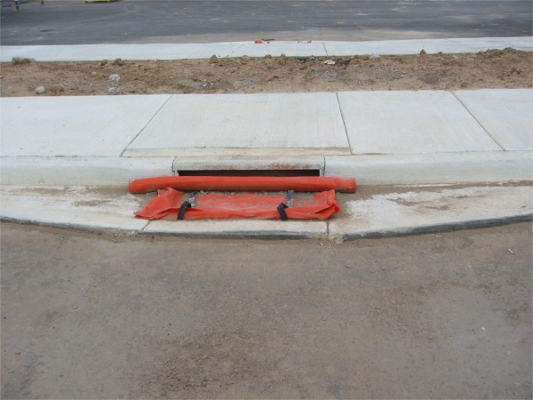
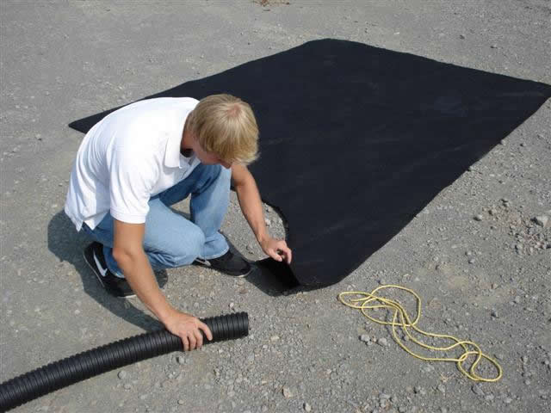
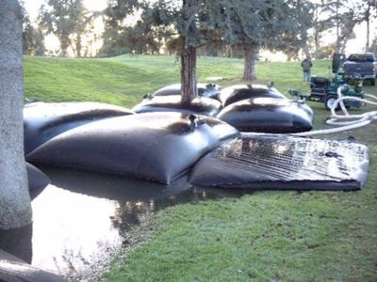
Photo 1: Silt Bag/Dewatering Bag

Photo 2: Full silt bag from dredging activity

Photo 3: Inlet Protection - Dandy Bag

